**Lab Report No : 02**

**Lab Report Name : Basic Command of Linux Operating System**

**Question : What is Linux command?**

**Answer :** Linux is a Unix-Like operating system. All the Linux/Unix commands are run in the terminal provided by the Linux system. This terminal is just like command prompt of Windows OS. Linux/Unix commands are case-sensitive. The terminal can be used to accomplish all Administrative tasks. This includes package installation, file manipulation, and user management. Linux terminal is user-interactive. The terminal outputs the results of commands which are specified by the user itself.

**Question : Write 15 commands of Linux operating system.**

**Answer :** There are a lot of Linux commands, 15 of them are given below,

1. ls
2. pwd
3. cd
4. chmod
5. df
6. du
7. mkdir
8. passwd
9. rm

10.in

11.tar

12.zip

13.cat

14.diff

15.gzip

**Question : Describe the operation of Linux basic command(screenshot).**

**Answer :** The operation of basic Linux command is given below :

1. ls : ls command is used for listing contents of a directory. It works as dir command.

Example :

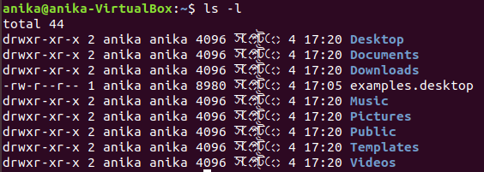

1. pwd : pwd command displays the name of current/working directory as below.

Example :



1. chmod : chmod command is used to change/update file access permissions like this .

Example:

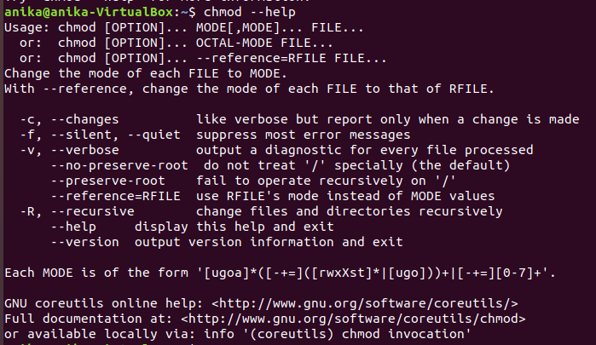

1. df : df command is used to show file system disk space usage as follows.

Example :

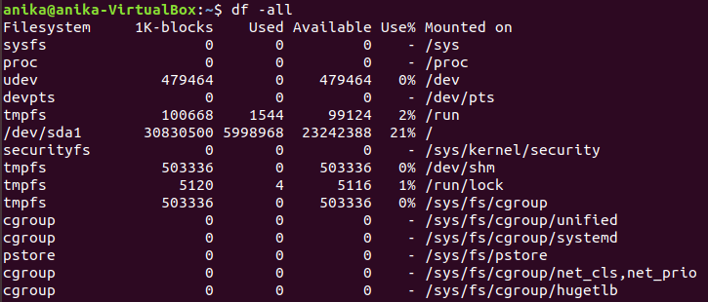

1. du : du command is used to show disk space usage of files present in a directory as well as its sub – directories .

Example :

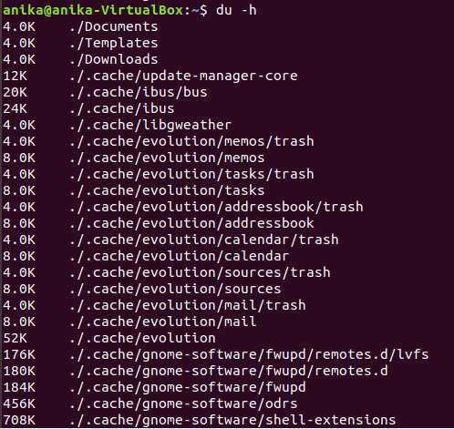

1. mkdir : mkdir command is used to create single or more directories, if they do not already exist (this can be overridden with the –p option).

Example :

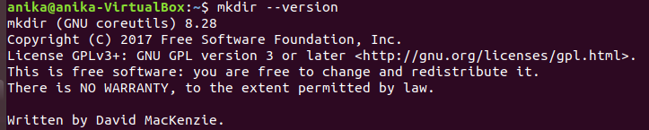

1. passwd : passwd command is used to create or update passwords for user accounts, it can also change the account or associated password validity period.

Example :

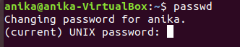

1. rm : rm command is used to remove files or directories .

Example :

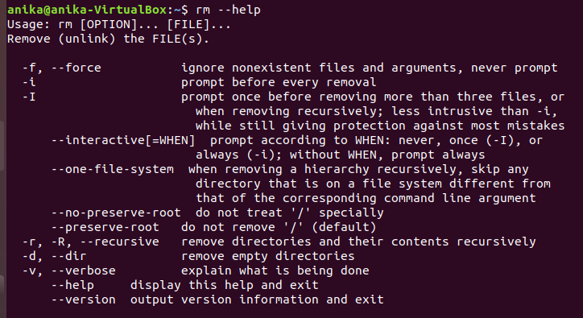

1. ln : ln command is used to create a soft link between files using the –s flag .

Example :

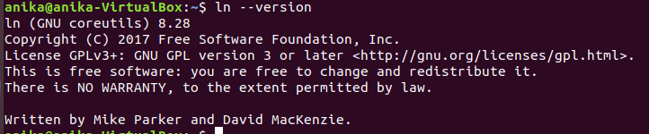

1. tar : tar command is a most powerful utility for archiving files in Linux.

Example :

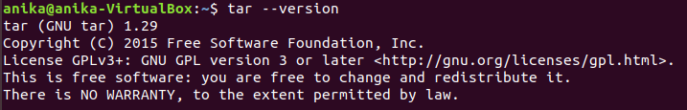

1. cd : cd stands for change directory and it does the same as it name stands for.

Example :

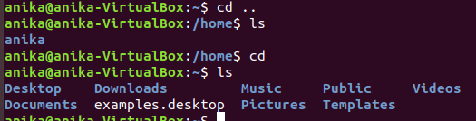

1. bzip2 : bzip2 command is used to compress or decompress files.

Example :

